Supplementary materials

A – The measurement methods and muscle parameters of the elbow

A1: measurement of the geometrical parameters

All muscles of the elbow were dissected from the cadaver after they were divided in multiple parts. The elbow muscles which pass through the hand were cut at the level of the retinaculum flexorum and extensorum. The geometrical parameters (including the origins and insertions of the muscles and ligaments, the shape and position of the bony contours, the rotation centers of the joints, and the position of the anatomical landmarks) were measured using a 3-D digitizer . Before dissection, at least four metal screws were put in all segments of the specimen and the positions of all these screws were measured in the intact body. From those measurements we obtained the global coordinate system and relative orientations of all segments. In subsequent measurements with the digitizer, the positions of the geometrical parameters were determined in their local coordinate systems as defined with the aforementioned screws and subsequently transformed from the local to the global coordinate system. The shape and position of the bony contours which determine the wrapping objects for the muscles were estimated by a least squares method. The flexion and pronation axes were calculated on the basis of screw axes. To determine the flexion axis, the orientation screws of the humerus (fixed to a frame), and ulna were measured at different elbow flexion angles. The rotation matrices and axes for each set of measurements were calculated by using the method in reference . The averaged rotation axis was then used as the elbow flexion axis. For the pronation axis, the radius was fixed to a frame and the orientation screw of the ulna and radius were measured at different pronation angles. Similar calculations as for the flexion axis were used to determine the pronation axis.

A2: measurement of muscle parameters

A2.1: measurement of sarcomere length

Sarcomere length was measured by the laser diffraction method. In this method, light is diffracted due to passing of the laser through the muscle fiber. The laser tube is positioned at a fixed distance from the wall on which the sarcomere length can be read from the calibrated scale. Measurement samples of the muscle fiber bundles with 1cm length were prepared. At each cross-section, about 10 fibers were selected. The samples were thin enough to let the laser light to shine through them. Before starting the measurements, it was checked that as long as the measuring sample is not pulled during the measurement, the sample preparation does not affect the sarcomere length. Considering the variations of the sarcomere length through the muscle fiber (up to about 0.2μm), the sarcomere length was measured at different places over the muscle fiber where the average value was used as the mean sarcomere length. The number of sarcomere was then calculated by dividing the measured muscle fiber length by the calculated mean sarcomere length.

The relative maximum forces as well as the actual sarcomere length of each muscle element were calculated at five flexion postures from 0 to 120º with the step of 30º while forearm was supinated. The relative force-sarcomere length curves of all elements of the biceps breve and anconeus muscles are shown in Figures A1 a-b.

A2.1: measurement of the muscle length, mass, and PCSA

For each muscle element, the length (l_{m}) between the two markers put at the origin and insertion was measured. From each muscle element, three fiber bundles were dissected and their lengths (l_{f}) were measured. The tendon length (l_{t}) was calculated as the difference between the total muscle length and the fiber length:

l_{t} = l_{m} - l_{f} (A1)

The mass of the muscle bellies without the tendons was measured as the muscle mass (m). The specific density of the muscles (δ) were previously measured by . Considering that the volume of the muscles remains constant during the contractions, the physiological cross sectional area (PCSA) was calculated as follows:

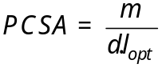 (A2)

Where, l_{opt} is the optimum fiber length.

The measured muscle parts of the elbow and their origins and insertions are summarized in Table A1. In Table A2, the muscle parameters of all elbow muscle elements including PCSA, mass and optimum fiber length are also given.

Table A1 - Measured muscle parts of the elbow and their origins and insertions

Muscle | No. elements | Origin | Insertion
m. biceps caput longum (BL) | 1 | humerus | radius
m. biceps caput breve (BB) | 2 | scapula | radius
m. triceps caput longum (TRL) | 4 | scapula | ulna
m. triceps caput mediale (TRM) | 5 | humerus | ulna
m. triceps caput laterae (TRLT) | 5 | humerus | ulna
m. brachialis (BR) | 7 | humerus | ulna
m. brachioradilais (BRD) | 3 | humerus | radius
m. anconeus (ANC) | 5 | humerus | ulna
m. supinator ulna-rad (SUP) | 5 | ulna | radius
m. pronator quadratus (PQ) | 3 | ulna | radius
m. pronator teres hum-rad (PT hum) | 1 | humerus | radius
m. pronator teres ulna-rad (PT uln) | 1 | ulna | radius

Table A2 - Muscle parameters including PCSA, mass, and optimum fiber length
Muscle name | Element no. | PCSA (cm²) | Mass (gr) | Opt. fiber length (cm)
BL | 1 | 3.47 | 66.20 | 12.92
BB | 1 | 1.73 | 20.79 | 11.70
 | 2 | 3.22 | 31.07 | 11.49
TRL | 1 | 2.23 | 26.97 | 10.08
 | 2 | 2.96 | 29.55 | 8.81
 | 3 | 2.83 | 29.64 | 11.83
 | 4 | 3.27 | 32.03 | 12.26
TRM | 1 | 2.63 | 18.40 | 8.07
 | 2 | 2.56 | 17.65 | 7.73
 | 3 | 2.40 | 11.95 | 6.02
 | 4 | 2.11 | 13.95 | 7.46
 | 5 | 1.07 | 7.70 | 8.07
TRLT | 1 | 1.53 | 12.50 | 7.58
 | 2 | 4.10 | 33.20 | 7.66
 | 3 | 2.19 | 15.20 | 6.56
 | 4 | 2.75 | 16.20 | 6.38
 | 5 | 0.87 | 5.85 | 6.38
BR | 1 | 3.14 | 29.10 | 8.76
 | 2 | 1.58 | 15.90 | 9.53
 | 3 | 1.57 | 14.65 | 8.70
 | 4 | 0.87 | 7.00 | 7.58
 | 5 | 1.01 | 6.60 | 6.19
 | 6 | 1.04 | 4.10 | 4.72
 | 7 | 1.18 | 6.50 | 6.21
BRD | 1 | 0.30 | 4.70 | 16.13
 | 2 | 0.82 | 14.00 | 16.13
 | 3 | 0.52 | 5.97 | 10.66
ANC | 1 | 0.31 | 0.83 | 2.52
 | 2 | 0.70 | 1.50 | 2.02
 | 3 | 0.25 | 0.60 | 2.28
 | 4 | 1.18 | 2.20 | 2.70
 | 5 | 1.18 | 3.33 | 2.66
SUP | 1 | 0.47 | 0.84 | 2.67
 | 2 | 2.32 | 3.64 | 1.48
 | 3 | 1.26 | 3.36 | 2.52
 | 4 | 1.48 | 2.96 | 2.63
 | 5 | 2.85 | 6.76 | 2.74
PQ | 1 | 0.73 | 1.63 | 3.77
 | 2 | 1.78 | 3.47 | 3.86
 | 3 | 2.19 | 4.93 | 3.52
PT hum | 1 | 5.10 | 27.50 | 5.10
PT uln | 1 | 1.41 | 4.33 | 3.91

Figure A1 - Relative maximum forces vs. sarcomere length in all elements of the (a) biceps caput breve and (b) anconeus muscles. The numbers 1 to 5 on each subfigure stand for the positions during flexion from 0 to 120 degrees (with step of 30 degrees) while the forearm is supinated.

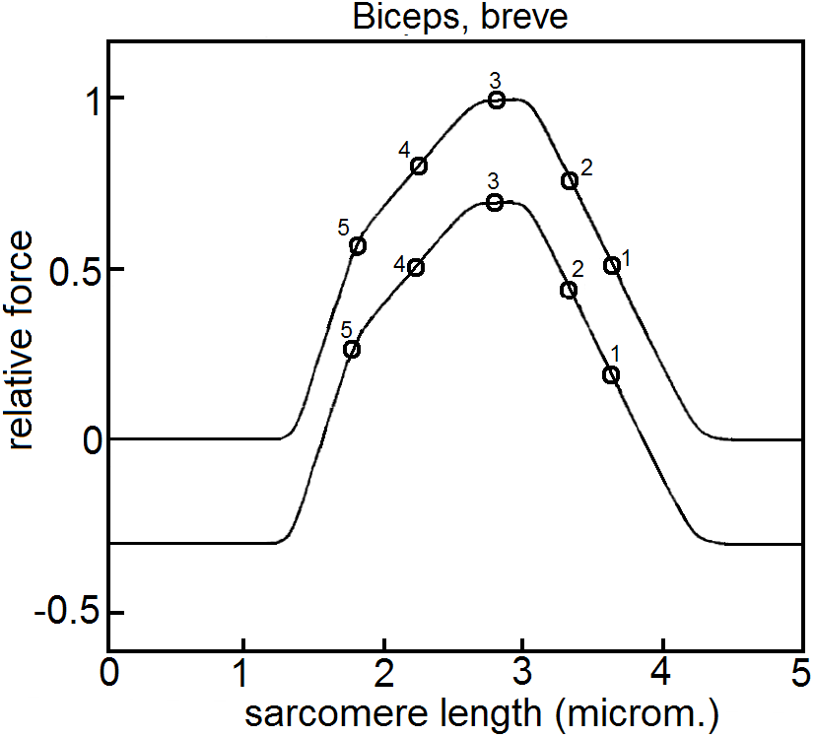
(a)

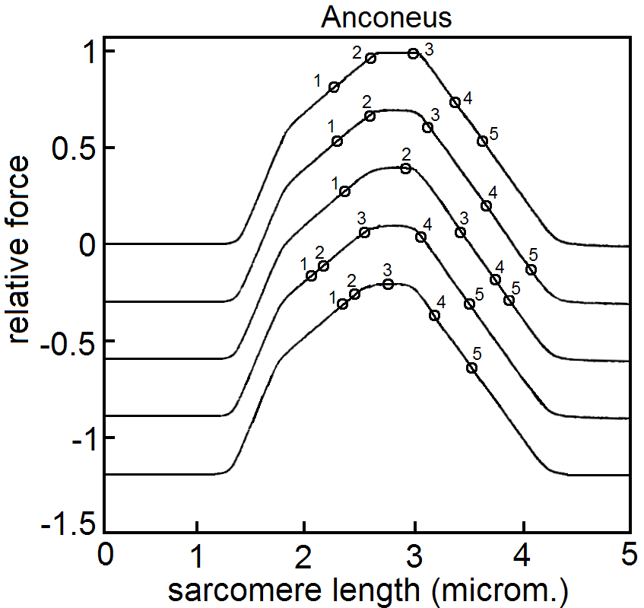
(b)

B – Kinematic optimization in the model
The morphology of the cadaver from which the geometrical parameters of the model were obtained may differ from the morphology of a measured subject. Important factors are the size of the scapula and clavicle, the shape of the thorax over which the scapula glides, and the length of the conoid ligament. If the model is not scaled to subject-specific geometrical parameters, the measured (Cardan) angles of the scapula and clavicle (with respect to the thorax) from the measured subject may result in model positions where the medial border of the scapula and the surface of the thorax do not fit and also the conoid ligament may have a non-physiological length. Therefore, there is a need to find the optimal model input angles which not only fit the model constraints but also have the smallest difference with the actually measured angles.

In the model, the clavicle is defined by the rotation centers of the sterno-clavicular (SC) and the acromio-clavicular (AC) joints and the origin of the conoid ligament. Four points including the trigonum spinae (TS) angulus inferior (AI), the AC, and the insertion of the conoid ligament define the scapula. Using the measured orientation of the scapula and clavicle, the constraints of the closed-chain mechanism are met and the differences between the subject’s and model orientation are minimized. These constraints include:

- the distance between the surface of the thorax (which is modeled as an ellipsoid, see reference ) and the points TS and AI must remain constant

- the length of the conoid ligament ( = 18.33 mm) must remain constant.

The position of the shoulder girdle is determined by minimizing the differences (d) between measured and optimized angles for the scapula and clavicle around the global

x- (dS_{x} and dC_{x}), y- (dS_{y} and dC_{y}), and z- (dS_{z} and dC_{z}) axes as follows:

EMBED Equation.DSMT4 (B1)

Where W₁ and W₂ are weight factors. The choice of the relative weight factors is subjective. The accuracy of estimation of the clavicular or scapular angles depends on these weight factors. de Groot concluded that using W₁ =1 and W₂ = 2 resulted in a slight improvement on the average scapular angles and notable improvement on the average axial rotation of the clavicle, when compared with actually measured angles.

C – The muscle model
The muscle model (Figure C1) consists of different parts as follows.
1) The activation dynamics part (Figure C1b) is a second-order system and includes the neural excitation (u) and calcium dynamics. The excitation (e), is analogous to the pulse transmissions along the nerves or action potentials along the muscle fibers (EMG) and is defined as the input to the model (assumed to be constant in each time-step) while the outputs of the model are the spatial positions of the bony segments. The excitation dynamics (e) is related to the neural excitation (u) through a first-order relation as follows:
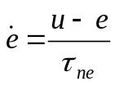 (C1)
where τ_{ne} (~ 0.04 s) is the neural excitation time-constant. Values of both u and e are restricted to the interval (0, 1).
The activation (a), which physiologically is interpreted as the calcium flow through the muscle membrane, is modeled by two first-order systems including muscle activation (calcium in-flow) and deactivation (calcium out-flow):
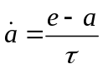 (C2)
where τ is the time constant which can be either used for muscle activation (τ_{act} ~ 0.01s) or deactivation (τ_{deact} ~ 0.05s).
2) The contractile dynamics part (Figure C1b) defining the muscle-tendon complex is a nonlinear first-order system and consists of a contractile element (the muscle fibers, CE) in series with an elastic element (a spring-like tendon, SE). The muscle force-length and force-velocity relationships have been implemented in the CE.
2.1. force-length relationship (F_{lCE})
The normalized force-length relationship is described by a Gaussian equation as follows:
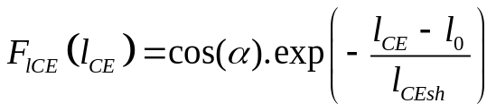 (C3)
Where:
α is the pennation angle which is function of the length of the contractile element (l_{CE}):
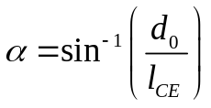 (C4)
d₀ is the muscle with due to pennation and is defined as:
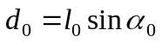 (C5)
l₀ is the optimum fiber length (optimum length of the CE).
l_{CEsh} is the shape parameter determining the width of the force-length curve.
Having the lengths of the CE (l_{CE}) and tendon (l_{t}), the length of the SE (l_{SE}) could be calculated as:
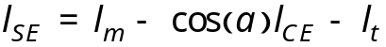 (C6)
Where l_{m} is the muscle length.
2.2. force-velocity relationship (F_{vCE})
F_{vCE}(a, l_{CE} , v_{CE} ) is the normalized force from the force-velocity relationship. In the muscle model, the contraction velocity of the CE (v_{CE}) is derived by inverting the force-velocity curve:

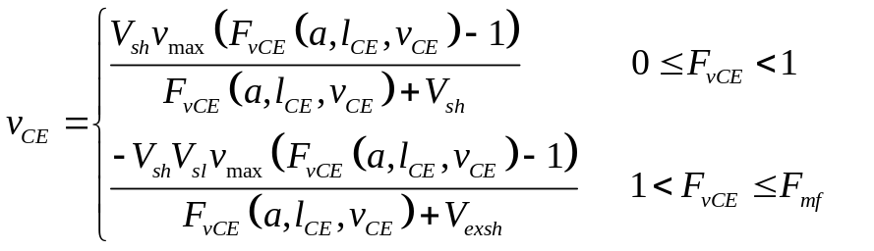 (C7)
Where
V_{sh} (= 0.25) is the Hill shape parameter of the force-velocity curve.
V_{sl} is the shape parameter of the lengthening curve.
V_{exsh} and v_{max} are calculated as follows:
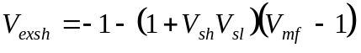 (C8)
and
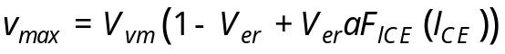 (C9)
Where
V_{vm} (~ 25 rad/s) is the initial value of the maximum contraction velocity, and
V_{er} is scaling parameter.
The muscle force produced in the contractile part (F_{SE}) is calculated as follows:
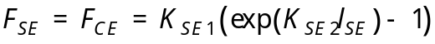 (C10)
The SE element is modeled with a non-linear spring in which:
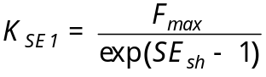 (C11)
and
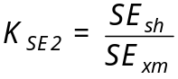 (C12) Where
SE_{sh} (= 3) is the shape parameter of the curvature of the exponential slope, and
SE_{xm} (~ 0.0201 m) is the stretch of the SE element with maximum isometric force.
3) The parallel viscoelastic element (PE)
The force produced in the PE element (F_{PE}) is a function of the muscle length and velocity and is calculated in a similar way to F_{SE} as follows:
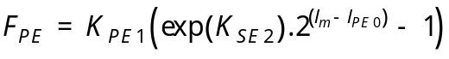 (C13)
where
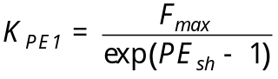 (C14)
and
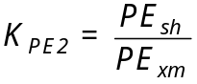 (C15) PE_{sh} is the shape parameter,
PE_{xm} is the maximum extension of the PE element,
l_{PE0} is the muscle rest length (maximum length when F_{PE} = 0)
The input variables
The values for time-constants (τ_{ne}, τ_{act}, τ_{deact}) and the other parameters (V_{sh},V_{vm}, SE_{sh}, SE_{xm}) were adopted from the studies by Winters and Stark .
The real muscle inputs are the pulse trains for different motor units. Nevertheless, it is not possible to record all these pulse trains. Therefore, a neural input (u) is defined representing the relative muscle force with respect to the maximum possible force during an isometric contraction. A measured EMG signal normalized to its maximum can be used as an average neural excitation (e) across different muscle fibers.
At each time-step, the neural excitation is calculated in an iterative procedure from the neural inputs at the previous step. The initial values are estimated in the quasi-static position and through the steady-state equilibrium process.
Figure C1 – (a) Schematic of the muscle model (reproduced from reference ), and (b) the activation and contraction dynamics parts of the muscle model
CE: contractile element, SE: series-elastic element, PE: parallel viscoelastic element
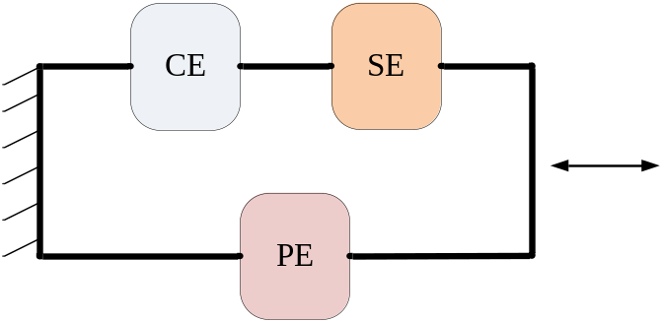
(a)
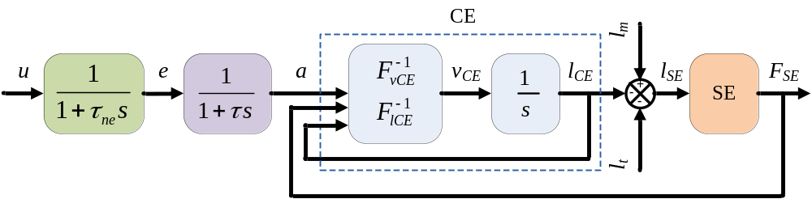
(b)
References
1. Pronk GM, Van der Helm FCT (1991) The Palpator: an instrument for measuring the positioning of bones in three dimensions. J Med Eng Tech 15(1):15-20
2. Veldpaus FE, Woltring HJ, Dortmans LJMG (1988) A least-squares algorithm for the equiform transformation from spatial marker co-ordinates. J Biomech 21(1):45-54
3. Klein Breteler MD, Spoor CW, Van der Helm FCT (1999) Measuring muscle and joint geometry parameters of a shoulder for modeling purposes. J Biomech 32(11):1191-1197
4. de Groot JH (1998) The shoulder: a kinematic and dynamic analysis of motion and loading. Delft: Delft University of Technology
5. Winters JM, Stark L (1985) Analysis of fundamental human movement patterns through the use of in-depth antagonistic muscle models. IEEE T Bio-Med Eng 32826-839
6. Winters JM, Stark L (1987) Muscle models: what is gained and what Is lost by varying model complexity. Biol Cybern 55403-420

